8/10/2020 Seminari 4
Exercici 1.Algorismes basics
Exercici 1.1.
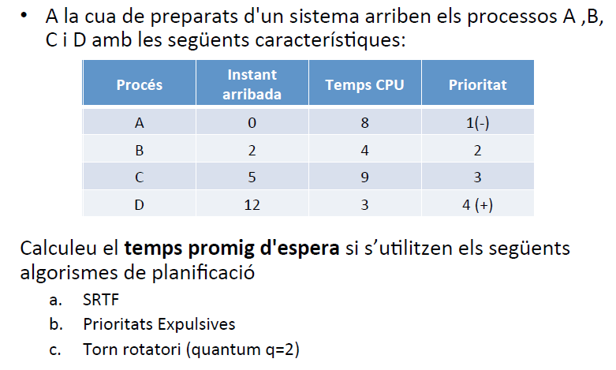
4/21
a)SRTF
Temps | Preparats | CPU | Comentari
0* | (A) | A(7) | Arriba A
1 |  | A(6)
2* | A | B(3) | Arriba B
3 | A | B(2)
4 | A | B(1)
5* | C A | B(0) | Arriba C
6 | C | A(5) | Acaba B
7 | C | A(4)
8 | C | A(3)
9 | C | A(2)
10 | C | A(1)
11 | C | A(0)
12* | C (D) | D(2) | Arriba D //Acaba A
13 | C | D(1)
14 | C | D(0)
15 |  | C(8) | Acaba D
16 |  | C(7)
17 |  | C(6)
18 |  | C(5)
19 |  | C(4)
20,,,,23 |  | C(3)… C(0)
Temps mig espera: (A*4 +B*0+C*10+D*0) / 4= (4+0+10+0) / 4 = 3,5
b) Prioritats expulsives
Temps | Preparats | CPU | Comentari
0* | (A) | A(7) | Arriba A
1 |  | A(6)
2* | A | B(3) | Arriba B
3 | A | B(2)
4 | A | B(1)
5* | AB | C(8) | Arriba C
6 | AB | C(7)
7 | AB | C(6)
8 | AB | C(5)
9 | AB | C(4)
10 | AB | C(3)
11 | AB | C(2)
12* | ABC(D) | D(2) | Arriba D
13 | ABC | D(1)
14 | ABC | D(0)
15 | AB | C(1) | Acaba D
16 | AB | C(0)
17 | A | B(0) | Acaba C
18 |  | A(5) | Acaba B
19 |  | A(4)
20 |  | A(3)
21 |  | A(2)
22 |  | A(1)
23 |  | A(0)
Temps mig espera: (A*16+B*12+C*3+D*0) / 4=(16+12+3+0) / 4 = 7,75

c) Torn rotatori // Round Robin (q=2)
Temps | Preparats | CPU | Comentari
0* | (A) | A(7) | Arriba A
1 |  | A(6)
2* | A | B(3) | Arriba B
3 | A | B(2)
4 | B | A(5)
5* | CB | A(4) | Arriba C
6 | CA | B(1)
7 | CA | B(0)
8 | A | C(8) | Acaba B
9 | A | C(7)
10 | C | A(3)
11 | C | A(2)
12* | A D | C(6) | Arriba D
13 | AD | C(5)
14 | CA | D(2)
15 | CA | D(1)
16 | DC | A(1)
17 | DC | A(0)
18 | D | C(4) | Acaba A
19 | D | C(3)
20 | C | D(0)
21 |  | C(2) | Acaba D
22 |  | C(1)
23 |  | C(0)
Temps mig espera: (A*10+B*2+C*10+D*6) / 4=(10+2+10+6) / 4 = 7

Exercici 1.2.
9/21
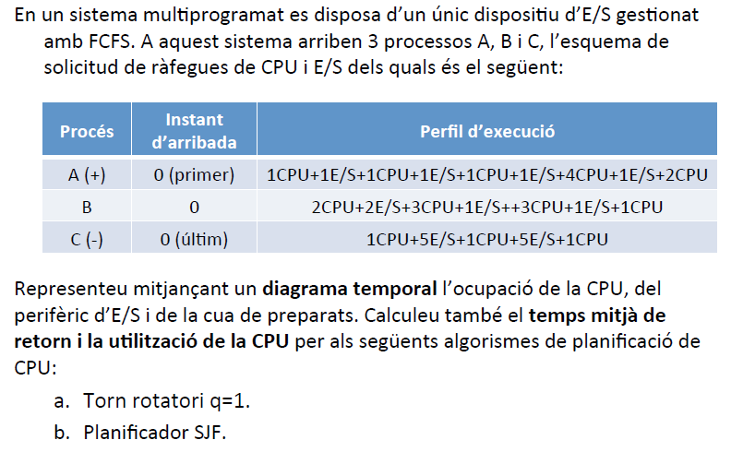
Mirar la taula blava i anar avançant poc a poc
a) RR q=1
Temps | Preparats | CPU | Cua I/O | I/O | Comentari
0* | CB(A) | A(0) |  |  | Arriba A B i C
1 | C | B(1) |  | A(0)
2 | BA | B(0)
3 | B | A(0) |  | C(4)
4 |  | B(0) | A | C(3)
5 |  |  | B A | C(2)
6 |  |  | B A | C(1)
7 |  |  | B A | C(0)
8 |  | C(0) | B | A(0)
9 |  | A(0) | C | B(1)
10 |  |  | A C | B(0)
11 |  | B(2) | A | C(4)
12 |  | B(1) | A | C(3)
13 |  | B(0) | A | C(2)
14 |  |  | B A | C(1)
15 |  |  | B A | C(0)
16 |  | C(0) | B | A(0)
17 |  | A(3) |  | B(0) | C acaba
18 | A | B(2)
19 | B | A(2)
20 | A | B(1)
21 | B | A(1)
22 | A | B(0)
23 |  | A(0) |  | B(0)
24 |  | B(0) |  | A(0)
25 |  | A(1) |  |  | B acaba
26 |  | A(0)
27 |  |  |  |  | A acaba
28
29
30

Temps de retorn: | TempsFinalitzacio – Temps Inici
TR (A) | 27 – 0 = 27
TR (B) | 25 – 0 = 25
TR (C) | 17 – 0 = 17
Temps Retorn mig: | (27+25+17) / 3 = 23

Exercici 2.Algorismes Multicua

Mirar diapos 28/29 i 29/29 de UT4 per a veure les multicues

17/21
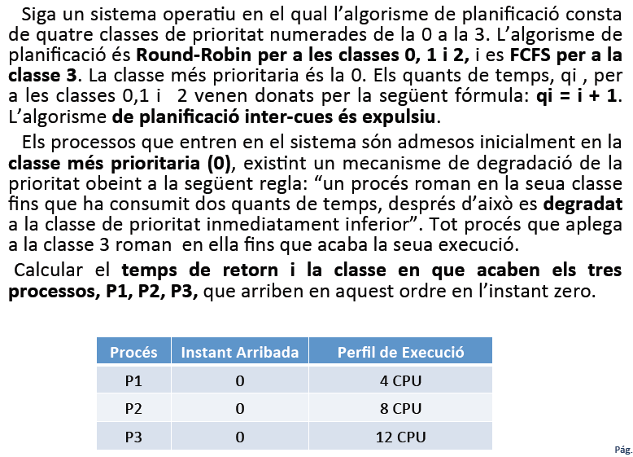

Enunciat
Proces | Perfil execucio
A | 4 CPU
B | 8 CPU
C | 12 CPU

Taula. 2 instants per cua.
Temps | Preparats |  |  |  | CPU | Comentari
Temps | Cua 3  FCFS | Cua 2  RR q= 3 | Cua 1  RR q= 2 | Cua 0  RR q= 1 | CPU | Comentari
0 |  |  |  | C B (A) | A(3) | Entren ABC
1 |  |  |  | A C | B(7)
2 |  |  |  | BA | C(11)
3 |  |  |  | C B | A (2)
4 |  |  | A | C | B (6)
5 |  |  | B A |  | C (10)
6 |  |  | C B |  | A(1)
7 |  |  | C B |  | A(0)
8 |  |  | C |  | B(5) | Acaba A
9 |  |  | C |  | B(4)
10 |  |  | B |  | C(9)
11 |  |  | B |  | C(8)
12 |  |  | C |  | B(3)
13 |  |  | C |  | B(2)
14 |  | B |  |  | C(7)
15 |  | B |  |  | C(6)
16 |  | C |  |  | B(1)
17 |  | C |  |  | B(0)
18 |  |  |  |  | C(5) | Acaba B
19 |  |  |  |  | C(4)
20 |  |  |  |  | C(3)
21 |  |  |  |  | C(2)
22 |  |  |  |  | C(1)
23 |  |  |  |  | C(0)
24 |  |  |  |  |  | Acaba C
25
26

Exercici 3. Multicua amb realimentació

20/21
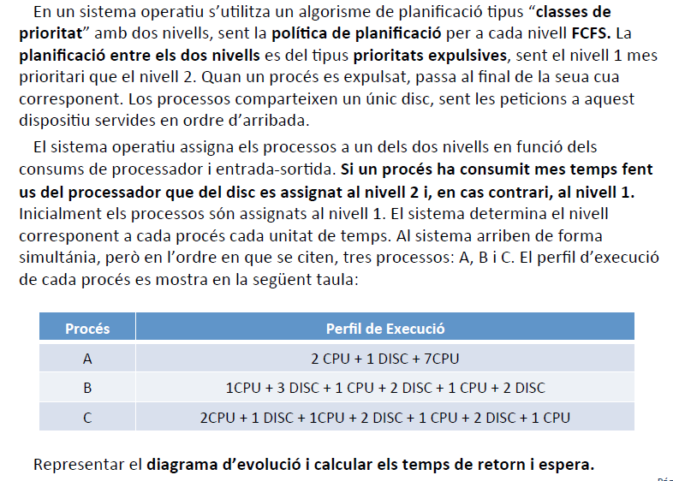
Proces | Perfil de execucio
A | 2 CPU+1 DISC+ 7 cpu
B | 1CPU+ 3 DISC+ 1 CPU + 2 DISC + 1 CPU + 2 DISC
C | 2 CPU+ 1 DISC+ 1 CPU + 2 DISC + 1 CPU + 2 DISC+ 1 CPU
Procesos nous van al nivell 1.

T | Preparats |  | CPU | Cua Disc | Disc | Comentari
T | Clase 2 | Clase 1
0 |  | C B (A) | A(1)
1 | A | C | B(0)
2 | A |  | C(1) |  | B(2)
3 | C |  | A(0) |  | B(1)
4 |  |  | C(0) | A | B(0)
5 |  |  | B(0) | C | A(0)
6 |  |  | A(6) | B | C(0)
7 | C |  | A(5) |  | B(1)
8 | C |  | A(4) |  | B(0)
9 | A C |  | B (0)
10 |  |  | C(0) |  | B(1)
11 |  |  | A(3) | C | B(0)
12 | A |  | B(0) |  | C(1)
13 |  |  | A(2) |  | C(0) | Acaba B
14 | A |  | C(0)
15 |  |  | A(1) |  | C(1)
16 |  |  | A(0) |  | C(0)
17 |  |  | C(0) |  |  | Acaba A
18 |  |  |  |  |  | Acaba C
19
20

Temps de retorn: | TempsFinalitzacio – Temps Inici
TR (A) | 17 – 0 = 17
TR (B) | 13 – 0 = 13
TR (C) | 18 – 0 = 18
Temps Retorn mig: | (17+13+18) / 3 = 16

